

UNIVERSITY OF GREENWICH
COMP1682
FINAL YEAR PROJECT
INDIVIDUAL REPORT

Student name | Vo Phuong Thuc
ID number | 001391527
Lecturer/Tutor name | TRAN THI KIM KHANH
Student submission date | ?????????????

Undergraduate Final Year Project

An experimental analysis of Flutter to develop an online cross-platform gaming communication space

Vo Phuong Thuc - 0001391527

Supervisor: Tran Thi Kim Khanh

Final Year Individual Project COMP1682
A dissertation submitted in partial fulfilment of the University of Greenwich undergraduate degree programme
BSc (Hons) Computing

Due Date: ???????

Word count: Insert number (10,000-12,000 not counting appendices)

Abstract
The global rise of the gaming industry has highlighted the need for a specialized social networking platform tailored to gamers. Traditional social media platforms like Facebook and X, while popular, fail to meet the specific communication and community-building needs of gamers. This project proposed a cross-platform solution designed to foster meaningful interactions within the gaming community. Key features included the formation of communities, content sharing, and communications, all aimed at enhancing collaboration and camaraderie among players. The platform has been tested for scalability and user satisfaction, confirming its effectiveness in providing a dedicated space for gamers to connect, share, and thrive.

Keywords: Gaming industry, social networking platform, gamers, communities, content sharing, cross-platform, specialized social media.
Acknowledgments
I would like to express my deepest gratitude to my supervisor, Mrs. Tran Thi Kim Khanh, for her unwavering support, patience, and insightful guidance throughout my research journey. Her expertise and direction have been invaluable in shaping and completing this thesis.
My sincere thanks also go to Mrs. To Ngoc Muoi, the examination officer of the IT department at the University of Greenwich, for providing crucial information and support during my graduation project. Her detailed insights into various subjects played a key role in defining the scope and depth of my research. The knowledge and resources she shared were instrumental in the successful completion of this work.
I would also like to extend my heartfelt thanks to Rémi Rousselet for his outstanding contributions to the Flutter community. His work, particularly in developing essential packages like Provider and Riverpod, significantly facilitated the development of my project and served as a great source of technical inspiration and support.
Lastly, my deepest gratitude goes to my father and mother. Their unconditional love, encouragement, and support have been the foundation of my strength throughout this journey. Without their unwavering support, this accomplishment would not have been possible.
Thank you all for your invaluable contributions and support.
Content
1 Introduction 1
1.1 Background 1
1.2 Aims 1
1.3 Objectives 2
1.3.1 Research & Analysis 2
1.3.2 Implementation: 3
1.3.3 Testing: 3
1.4 Approach methodology 4
1.4.1 SDLC model 4
1.4.2 Planning 4
2 Literature Review 8
2.1 Approaches to literature searching 8
2.2 Cross-platform development vs native development 9
2.3 THE IMPACT OF SOCIAL MEDIA ON MODERN SOCIETY 10
2.4 EXISTING SOCIAL NETWORKS ASPECTS ANALYSIS 11
2.5 Tools and Technologies 12
2.5.1 Back-end programming languages 12
2.5.2 Cross-platform frameworks 14
2.5.3 Backend-as-a-service 15
3 Review of Other similar products 18
3.1 Introduction 18
3.2 Product 1 18
3.2.1 Overview 18
3.2.2 Appearance 18
3.2.3 Usability 18
3.3 Product 2 18
3.4 Product 3 18
3.5 Conclusions 18
4 LEGAL SOCIAL ETHICAL AND PROFESSIONAL ISSUES 19
4.1 Legal 19
4.2 social 20
4.3 Ethical 20
4.4 Professional 20
5 Requirements Analysis 21
6 Design Development 22
6.1 Introduction 22
6.2 Architecture 23
6.3 Technical design 26
6.3.1 Use case 26
6.3.2 Sitemap 26
6.3.3 Activity diagram 27
6.3.4 Class Diagram 35
6.3.5 Entity Relationship Diagram 35
7 Prototype 36
7.1 Introduction 36
7.2 Low-fidelity prototypes 36
8 IMPLEMENTATION 37
8.1 Introduction 37
8.2 Implementation Issues 37
9 PRODUCT TESTING/TEST DATA 38
9.1 Introduction 38
9.2 Test cases 38
10 Evaluation 39
10.1 Introduction 39
10.2 Heuristic Evaluation (use Jakob Nielsen’s 10 usability heuristics in UI/UX design - HCI) 39
10.3 Usability Testing 39
11 Critical Appraisal 40
12 Conclusion 41
REFERENCES / BIBLIOGRAPHY 42
APPENDIX A. Project Proposal 45

Introduction

Background
As the gaming industry continues to expand globally, gamers have emerged as a prominent international community, driving a growing demand for platforms that address their communication needs (Marthasari, Suharso and Ardiansyah, 2018). While widely-used social media platforms like Facebook and Twitter have historically been popular among users due to their vast user base (Kaplan and Haenlein, 2010); they are increasingly falling out of favor as they fail to meet the specific needs of gamers. Despite the abundance of content on social networks, they often lack a dedicated focus on particular communities. Although various algorithms have been developed to identify communities within social networks, the increasing scale of these networks as more data is gathered has rendered traditional algorithms insufficient for community detection in large-scale social networks (Zhao, Liang and Wang, 2021). Consequently, developing a social networking platform exclusively for a particular community, such as gamers, offers a space for interaction, learning, and experience sharing among like-minded individuals.
By concentrating on the gaming community, these platforms offer a secure and welcoming environment where players can feel recognized and appreciated for their interests. Gamers have the opportunity to join and engage in existing communities or create their own smaller groups within the platform. Within these communities, they can share a variety of content, including text, images, videos, and files, for multiple purposes. Additionally, when the platform supports live streaming and allows users to freely upload videos, gamers can become content creators, enriching the interactive experience for the gaming community. Features like live streaming, content sharing, and community creation enable players to participate in discussions, events, and gaming-related activities naturally and flexibly.

Aims
This project aims to develop a comprehensive, cross-platform social networking platform specifically designed for the gaming community. By facilitating connections and interactions among gamers globally, it aims to create a dynamic environment that enhances communication, collaboration, and a sense of camaraderie within the gaming community.

Objectives

Research & Analysis

Research and analyze existing online social networks and their functions using academic documents to derive the requirements for a social network [7.0].

Write a literature review about the aspects of a social network system as well as its development platform, then analyze and conclude [4.0].

Systematically list in detail the functional requirements and non-functional requirements that the social network system should have based on researched and analyzed documents [2.0].

Verify whether the requirements are reasonable by conducting primary research to collect opinions from a population interested in social networks and identify core requirements [3.0].

Analyse the database needed for the system based on functional and non-functional requirements and ensure that there must be relationships and data constraints between tables [5.0].
Outcome: The phase yielded comprehensive insights and requirements for developing a robust social network system, validated through both academic literature and primary research.

Implementation:

Optimize user experience by building the project's core interfaces through integrating widgets and interface components. [12.0]

Develop user-related functionalities such as registration/login, as well as account customization and friend/unfriend with other people. [20.0]

Construct functionalities enabling users within the system to interact with each other, such as CRUD operations for posting, reacting, commenting, and sharing others' posts. [20.0]

Build features to enhance interaction among users, including messaging, live streaming, and joining groups. [45.0]

Facilitate system-wide search by implementing search functionalities based on keywords, hashtags, posters, and posting times. [15.0]
Outcome: This phase focused on optimizing user experience and developing a comprehensive set of user-related functionalities and features to enhance interaction, fostering a dynamic and engaging social networking environment.

Testing:

Web and mobile application testing by checking compatibility, and basic functionality to ensure application stability. [6.0]

Conduct user acceptance testing by focusing on appeal and user experience to improve app interactivity and friendliness. [4.0]

Conduct content management testing by reviewing the appropriateness of posted content for users and ensuring effective content management. [3.0]

SEO (Search Engine Optimization) testing to ensure that the application is optimized to increase its searchability on search engines. [2.0]
Outcome: A comprehensive web and mobile application testing ensured application stability and security, complemented by user acceptance testing focusing on improving interactivity and appeal. Additionally, content management and SEO testing were conducted to enhance user experience and increase the application's visibility.

Approach methodology

SDLC model
Building upon the principles of Agile, according to (Scrum.org, n.d.), the Scrum framework was first introduced in 1995 as a more effective teamwork method for solving complex problems. A Scrum Team comprises a product owner, a Scrum master, and a development team. These teams are typically cross-functional and self-organizing, rather than directed by external management. Designed to be adaptable, Scrum teams operate with high creativity and efficiency. The product is developed in iterative cycles, allowing for customer feedback with each completed increment (Zayat and Senvar, 2020).

Planning
Before starting the project, the author thoroughly researched the Scrum methodology to enhance the development process. Scrum was selected for its adaptability and emphasis on delivering value early in the project. This methodology also encourages close collaboration between the author and stakeholders, promoting continuous communication and feedback. For this particular project, Scrum offers a structured yet flexible framework, allowing for effective management of time and resources while optimizing the final product to meet both functional and non-functional requirements.
During the planning phase, the author used Microsoft Project to create a comprehensive Gantt chart, outlining all project stages, including Research & Analysis, Implementation, and Testing. Time estimates for each task in the Gantt chart were calculated by the author, considering factors such as complexity, difficulty, and prior experience with similar tasks. Additionally, the author accounted for potential disruptions or external influences that could affect the project timeline, ensuring that deadlines were realistic and achievable. Since this is a personal project, the author also took into account their availability and other commitments to maintain a balanced workload and practical scheduling.
Table 1. Overview of the project
Task Name | Duration | Start | Finish
An experimental analysis of Flutter to develop an online cross-platform gaming communication space | 151 days | Fri 15/03/24 | Mon 12/08/24
Research & Analysis | 21 days | Fri 15/03/24 | Thu 4/04/24
Implementation | 112 days | Mon 8/04/24 | Sun 28/07/24
Testing | 15 days | Mon 29/07/24 | Mon 12/08/24

This table provides an overview of the project schedule, including a detailed plan for the development of the project. It is divided into three main phases: Research & Analysis, Implementation, and Testing. Each phase has a specific expected time, from requirements research and analysis to final implementation and testing.

Table 2. Research & Analysis phase
Task Name | Duration | Start | Finish
Research & Analysis | 21 days | Fri 15/03/24 | Thu 4/04/24
Research and analyze existing online social networks and their functions using academic documents to derive the necessary requirements for a social network. | 7 days | Fri 15/03/24 | Thu 21/03/24
Write a literature review about the aspects of a social network system as well as its development platform, then analyze and conclude. | 4 days | Fri 22/03/24 | Mon 25/03/24
Systematically list in detail the functional requirements and non-functional requirements that the social network system should have based on researched and analyzed documents. | 2 days | Tue 26/03/24 | Wed 27/03/24
Verify whether the requirements are reasonable by conducting primary research to collect opinions from a population interested in social networks and identify core requirements. | 3 days | Thu 28/03/24 | Sat 30/03/24
Analyse the database needed for the system based on functional and non-functional requirements and ensure that there must be relationships and data constraints between tables | 5 days | Sun 31/03/24 | Thu 4/04/24
The detailed schedule for the Research & Analysis phase provides an overview of the specific activities and tasks performed to research and analyze the requirements of the social network system. This phase includes tasks such as researching and analyzing existing online social networks, writing a review article on aspects of a social networking system as well as its development platform, and especially listing detailed functional and non-functional requirements based on researched documents.

Table 3. Implementation phase
Task Name | Duration | Start | Finish
Implementation | 112 days | Mon 8/04/24 | Sun 28/07/24
Optimize user experience by building the project's core interfaces through integrating widgets and interface components. | 12 days | Mon 8/04/24 | Fri 19/04/24
Develop user-related functionalities such as registration/login, as well as account customization and friend/unfriend with other people. | 20 days | Sat 20/04/24 | Thu 9/05/24
Construct functionalities enabling users within the system to interact with each other, such as CRUD operations for posting, reacting, commenting, and sharing others' posts. | 20 days | Fri 10/05/24 | Wed 29/05/24
Build features to enhance interaction among users, including messaging, livestreaming, and joining groups. | 45 days | Thu 30/05/24 | Sat 13/07/24
Facilitate system-wide search by implementing search functionalities based on keywords, hashtags, posters, and posting times. | 15 days | Sun 14/07/24 | Sun 28/07/24

The Implementation schedule details the steps taken to develop the project's main functions and interfaces. This process lasts for about 112 days, starting from 04/8/24 to 07/28/24. Specific tasks include optimizing user experience by integrating interface elements, developing user-related functions such as registration/login, account customization, and making friends/ unfriend others, as well as building user interaction features such as CRUD operations to post, react, comment, and share other people's posts. New features such as messaging, live streaming, and group participation are also integrated to enhance user interaction. Finally, the system will be upgraded with system-wide search capabilities by implementing search functions based on keywords, hashtags, posters, and posting time. When this phase is completed, the product is considered complete and awaits testing.

Table 4. Testing phase
Task Name | Duration | Start | Finish
Testing | 15 days | Mon 29/07/24 | Mon 12/08/24
Web and mobile application testing by checking compatibility, and basic functionality to ensure application stability and safety. | 6 days | Mon 29/07/24 | Sat 3/08/24
Conduct user acceptance testing by focusing on appeal and user experience to improve app interactivity and friendliness. | 4 days | Sun 4/08/24 | Wed 7/08/24
Conduct content management testing by reviewing the appropriateness of posted content for users and ensuring effective content management. | 3 days | Thu 8/08/24 | Sat 10/08/24
SEO (Search Engine Optimization) testing to ensure that the application is optimized to increase its searchability on search engines. | 2 days | Sun 11/08/24 | Mon 12/08/24

The project's Testing phase is implemented by following Social Testing principles including specific tasks to ensure the stability and safety of the application. This process includes the following steps: testing for compatibility, basic functionality, and security of the application, to ensure stability and safety for users. Testing tasks also focus on improving user experience and user experience user-friendliness of the application, through conducting user acceptance testing and effective content management. Finally, SEO testing is performed to ensure the application is optimized for increased searchability search on search engines.

Literature Review

Approaches to literature searching
To build a comprehensive and in-depth understanding of the topics related to the project, a systematic and multifaceted approach to literature search and branching literature reviews was used by the author.
The authoritative literature sources of particular interest included popular scholarly databases such as Google Scholar, Semantic Scholar, and IEEE Xplore, which provide access to numerous peer-reviewed journals, conference papers, and in-depth analyses related to cross-platform development, native development, the impact of media on modern society, and finally aspects of modern world social networks. The author implemented a keyword search strategy by identifying terms and phrases relevant to the research topic, such as "cross-platform development", "native application development" "social network impacts on society", "digital transformation" and "misinformation". In addition, boolean operators (AND, OR, and NOT) are used frequently to refine search results and ensure that the retrieved results are closely related to the research topic.
In addition, citation and reference tracking is also used by the author to identify in-depth or groundbreaking works that have been referenced by other researchers. This method proves to be extremely effective as it can provide a broader context for research topics.
However, careful selection and selection of sources is an important factor in keeping the research relevant and trustworthy. The quality of sources is assessed based on the reputation of the journal, the impact factor, and the expertise of the author. Only sources published within the last five years are considered by the author, ensuring that the research is based on data that is not too old. The author pays special attention to studies that provide empirical data or systematic reviews, such as the works of Kuitunen (2019) and Shevtsiv and Striuk (2021).
Not to mention the large amount of literature, a tool to manage and organize a large volume of referenced literature is essential. Specifically in the author's case, Zotero was used, which allows easy storage of annotations and retrieval of sources, facilitating the writing process and ensuring proper citation throughout the research process.

Cross-platform development vs native development
As claimed by (Blanco and Lucrédio, 2021), smartphones have become increasingly ubiquitous and are utilized in various aspects of life, leading to a surge in demand for the development of new mobile applications or the migration of existing ones to mobile platforms. To meet this demand, numerous approaches have been proposed, such as native and cross-platform, as highlighted by Zohud and Zein (2021).
With the mobile application market becoming one of the largest branches of the software industry (Kuitunen, 2019), the opportunity of a native programmer is huge. However, native development has its challenges and opportunities that programmers must research and understand. For instance, in the opinion of (Shevtsiv and Striuk, 2021), native development holds an advantage over cross-platform development in terms of the availability of academic literature, courses, and market demand (especially in Ukraine). In the opposite direction, native development has its challenges. (Kuitunen, 2019) analyzed those developing native applications requires a large amount of knowledge about many platform-specific technologies, increasing the need for expertise and knowledge. Not to mention, native development often has higher development costs because the iOS version of the app has very different code and logic than the Android version even though it's the same app (Brito et al., 2018).
On the side of cross-platform development, Flutter's performance is a strong point as it can compile Dart source code into platform-specific machine code, allowing the application to run smoothly (Fentaw, 2020). demonstrated by (Nawrocki et al., 2021), by performing better CPU usage analysis and completing tasks more quickly than native development. Another advantage of cross-platform development is that it allows application development on multiple platforms (iOS, Android) on a single source code (Fentaw, 2020). However, application size can be a major obstacle to cross-platform development. Based on tests conducted by (GÜLCÜOĞLU, USTUN, and Seyhan, 2021), a simple “Hello World” application on Flutter is 4.7 MB in size, and React Native is 7 MB, this could be a significant barrier when the application size built with Kotlin or Java can be very low (around 3 MB for a 'Hello World' app).
In summary, both native and cross-platform development methodologies offer unique advantages and challenges, and developers must carefully consider their project requirements and constraints before making a decision.

THE IMPACT OF SOCIAL MEDIA ON MODERN SOCIETY
With the rapid development of technology (Ariantini et al., 2021), many studies have been conducted to assess the impact of social media on society today. These studies are conducted to evaluate those aspects in which social networks can negatively or positively affect users.
In modern society, the use of social networks is more than ever, and they have become the most popular medium for everyday communication (AminiMotlagh, Shahhoseini and Fatehi, 2022). With the vast amount of information being posted every second on platforms, the truthfulness of information is a dilemma. In addition, the use of social media as an entertainment tool makes it nearly impossible for users to distinguish between Fake news (FN) and True news (TN) (Olan et al., 2022), making FN a tool for manipulating/directing a group of people to advance an ideology by stimulating strong beliefs and social polarization.
As discovered by (Karim et al., 2020), Social media is a factor that can impact people's mental health, both in terms of the quantity and quality of social media relationships is a factor that can affect mental health, health behavior, physical health, and mortality risk. However, social media also serves as a tool to post and share your personal feelings, from the findings of (Zhou et al., 2021) research on emotional motivation amid the COVID-19 pandemic at its peak shows that people's sentiment remains quite positive amid the negative.
Social media also plays an incredibly important role in a business's digital transformation, the research performed by (Dwivedi et al., 2023) proved that the process of digitization makes customers more and more informed and less dependent on traditional sales initiatives. Based on the survey, 82% of buyers will look to content on social media to decide their buying behavior, putting pressure on B2B salespeople and traditional sales organizations (Ancillai et al., 2019). Demonstrate the undeniable role of social media in the way businesses operate in modern society.
In conclusion, through the evaluation of the conducted studies, it is evident that the role of social media in modern society is undeniable. While social media brings numerous benefits in communication, information sharing, and business development, it also poses potential issues such as impacts on mental health, the spread of misinformation, and increased reliance on technology. Additionally, the research indicates that social media can play a significant role in maintaining a positive mood and creating new business opportunities. However, there is a need for continued research and the development of effective strategies to manage the impacts of social media and harness their potential in modern society.

EXISTING SOCIAL NETWORKS ASPECTS ANALYSIS
Social networks (SNs) have become an integral part of modern digital life, facilitating communication, information sharing, and social interaction on a global scale. The influence of social media can include many aspects such as socializing, advertising, finding jobs, and even business (Aichner et al., 2021). As the popularity of social media continues to soar, more and more studies are done to focus on analyzing their aspects.
One of the factors determining the popularity of social networks today comes from many factors, but a few that stand out are hashtags (#), a character preceded by text (#comedy), used to query to find posts with specific hashtags (Antonakaki, Fragopoulou and Ioannidis, 2021). Popular hashtags can be used as trending topics to represent popular events happening in the world such as politics, public awareness, and brand promotion, so these trends are sensitive to malicious users to mislead the mass audience (Kausar, Tahir and Mehmood, 2021).
Additionally, the fast, real-time delivery of breaking information on the platform's most-discussed topics has allowed journalists and business analysts to discover and predict candidate popularity and product reviews (Kausar, Tahir, and Mehmood, 2021). However, in the wake of the disaster, most recently COVID-19 has shown that since the outbreak, the number of searches for "Handwashing" on social media platforms has increased rapidly, along misinformation about COVID-19 has also increased in popularity (Wang et al., 2020).
Moreover, with these effects, social messaging has also evolved into a major communication tool, the most notable trend over the past decade being the dramatic increase in the use of social media and online messaging platforms (Lee, Rojas and Yamamoto, 2022). This reflects a change in the way modern humans interact and communicate in daily life. A good example is how social media has partly shown how it can replace traditional teaching methods, especially in the context of the COVID-19 pandemic, teachers and students have chosen to use the Internet to adapt to the situation at that time (Uong, Nguyen and Nguyen, 2022).
Shortly, these aspects of social media have become an integral part of most of the population in today's digital life, offering significant benefits in communication, information sharing, and person-to-person interaction. Furthermore, social media can even create an environment that can temporarily replace traditional teaching methods in the context of the COVID-19 pandemic. However, findings from studies have shown that social media can also create challenges, such as the spread of misinformation in trending hashtags, as well as the psychological and physical health of spending too much time online.

Tools and Technologies
During the planning process, the author carefully researched the relevant technologies for the product development process corresponding to each part of the project, including the backend, front-end, and other supporting technologies. Each technology was considered based on criteria such as performance, learning curve, scalability, suitability for project requirements, and potential risks. Below are the technologies that were considered and analyzed for these items.

Back-end programming languages

Go
Based on Golang (Go) documentation (Go.dev, n.d.), Go was first introduced in 2009 by Google and is a language known for its expressiveness, simplicity, and efficiency. Its concurrency features make it ideal for optimizing performance on multicore and networked systems, while its unique type of system supports the creation of flexible, modular programs.
Hence, as introduced by (Go.dev, n.d.), the programming language offers the speed of compiled machine code, combined with the convenience of garbage collection and the capabilities of run-time reflection. It is a fast, statically typed language that retains the ease of use typical of dynamically typed, interpreted languages.
As a result, fast compilation comes at a cost. According to the analysis of Nabiil et al. (2023), Go's fast compilation results in excessive resource consumption (CPU usage/Memory usage). This creates a careful consideration for programmers when choosing the technology for their projects.

Java
Java is a programming language published by James Gosling and his team from Sun Microsystems in 1991 and released in 1995, notable for its ability to run on many different platforms without changing the source code.
Java is a versatile, strongly typed language that encourages correct programming practices. It’s known for being relatively easy to write, compile, debug, and learn compared to languages like C or C++. Java's platform independence, robust security features, and support for multi-threading make it a popular choice for developing reliable, distributed applications. Its use of Object-Oriented Programming (OOP) allows for the creation of reusable code, and its rich API facilitates tasks like database connection and networking. Java also benefits from extensive community support, making it easier for learners to find help. Despite similarities to C and C++, Java omits complex features like pointers and multiple inheritance, simplifying the learning curve.
Nevertheless, Java, while strong in many areas, has its drawbacks, including high memory usage and slower performance compared to C or C++. Its focus on storage rather than data backup, verbose code, and challenges in developing GUIs for desktop applications are notable limitations. Additionally, Java's memory management can be costly due to its large memory requirements.
(Khoirom et al., 2020)

Node.js
According to Challapalli et al. (2021), Node.js is a server-side coding language built on Chrome's JavaScript runtime. It allows JavaScript to be executed outside of a browser, facilitating the rapid and scalable development of network applications, with Express.js being a prominent framework.
What distinguishes Node.js from other technologies is its effective balance between developer productivity and application performance, enabling developers to rapidly create production-ready applications using the vast array of modules in the NPM package repository, as highlighted by Sun et al. (2018).
Also as stated by Sun et al. (2018), nonetheless, Node.js faces a significant limitation due to its lack of effective tools for analyzing program behavior and performance. Unlike other modern runtimes, Node.js does not support in-depth runtime analysis, making it difficult to profile applications, detect data races, or analyze memory usage. This issue becomes more pronounced in Node.js applications that rely heavily on third-party modules from NPM, where the inability to dynamically analyze these modules can lead to performance penalties and undetected issues in production.

Cross-platform frameworks

React Native
As a native scripting framework, React Native is used for cross-platform mobile application development. Initially developed and released by Meta (formerly Facebook) in 2015 exclusively for the iOS platform, the framework has since seen active contributions from the community, adding Android support and many other enhancements to the open-source project (Kuitunen, 2019).
According to the analysis of (Avdic, 2019), one of the biggest advantages of React Native is its rendering using the platform's standard API. This native rendering technique is not used by other cross-platform frameworks. Additionally, changes in the mobile application can be previewed immediately. This is particularly important because developers need feedback on their projects. There is also a powerful debugging tool integrated into the framework that uses the browser to display debugging information.
Despite, the performance of the React Native framework, as measured in an analysis by Axelsson and Carlström (2016), indicates that React Native typically requires more resources than a native Android application. They also concluded that this is an acceptable trade-off when considering the ease of developing applications for both Android and iOS using this framework (Eskola, 2018).

Xamarin
Xamarin, first introduced in 2011, was born as a community effort to port .NET libraries and the common language runtime compiler to different operating systems. The initial efforts aimed to create a set of binaries for developing, compiling, and running applications using C#, the native language of .NET, on Unix-based platforms (Bilgin, 2016).
An analysis conducted by Avdic (2019) indicates that one of the strengths of Xamarin is its ability to reuse code, saving time and effort for projects. Additionally, being built on C#, a modern language widely known in the programming community, makes finding information and solutions relatively simple.
However, also based on Avdic's research (2019) the Xamarin framework requires installation files to include links and references so that all mobile operating systems can function correctly. This can lead to large file sizes, ranging from 3 megabytes to 15 megabytes. Due to this issue, the time required to download the application or initialize it may need to be considered. Additionally, a significant portion of the development time in a Xamarin project is often spent on UI development. Although there is a large proportion of shared code, coding for each independent platform still requires a considerable amount of time.

Flutter
Flutter is a versatile UI toolkit designed for cross-platform development, enabling code reuse across various operating systems like iOS and Android. It allows applications to interact directly with platform-specific services, aiming to provide developers with the tools to create high-performance apps that feel native on each platform while maximizing code sharing.
During the development process, Flutter apps operate within a VM that supports stateful hot reload, enabling changes without requiring a full recompilation. Flutter apps are compiled into machine code for production, whether for Intel x64 or ARM architectures or JavaScript for web deployment. The framework is open-source under a permissive BSD license and is supported by a robust ecosystem of third-party packages that extend its core functionality.
(Flutter Documentation, 2024)
According to Wu's analysis (2018), Flutter is a unique framework. Instead of using WebView or relying on the device's OEM widgets, it renders all components with its high-performance rendering engine. This allows the creation of applications with performance comparable to native apps.
Additionally, Wu concluded that stateful hot reload is one of the key factors driving the development cycle. Hot reload is essentially achieved by injecting new source code into the running Dart virtual machine without altering the application's internal architecture, ensuring that all application transitions and actions remain intact afterward.
However, Flutter has its drawbacks. Based on Fentaw's research (2020), being built on the Dart programming language can be considered questionable as this is a programming language that is not very popular, and the programming community is not too large, although it is developing rapidly, that is a story of the future.

Backend-as-a-service

Supabase
Based on Ayezabu's definition (2022), Supabase was first launched in 2020 as an open-source alternative to Firebase. It is a platform that offers a suite of tools and services for building applications, including authentication, databases, file storage, automatically generated APIs and edge functions. The Supabase client libraries are supported in JavaScript, Python, and Dart.
One of the features that makes Supabase stand out among BaaS platforms is its automatically generated API based on the database, a feature unique to Supabase. These APIs include automatically generated documentation that updates whenever there are changes to the database. This significantly simplifies the integration of Supabase for clients.
Additionally, Supabase also supports self-hosting, allowing developers to deploy and manage Supabase infrastructure independently. This is a major advantage as it offers personalization to meet developers' needs and removes vendor lock-in, ensuring that developers are not entirely dependent on the service provider.

AWS Amplify
First introduced in 2017, as a full-stack platform for developing web and mobile applications, AWS Amplify is built on Amazon Web Services (AWS) and has access to over 175 AWS services (Uunonen, 2023). A powerful tool for front-end developers, Amplify can be used to deploy full-stack, cloud-based applications. It offers features such as data modeling, authentication, storage, serverless functions, and Server-side rendering application deployment (Amazon Web Services, 2024).
According to an analysis by Ivanov and Petrova (2024), serverless computing on AWS is particularly well suited for real-time data processing and analytics, allowing applications to process data streams with minimal latency. It also excels at supporting web and mobile backends by simplifying application development and scaling. With AWS Amplify, developers can quickly build and deploy serverless applications that integrate with multiple AWS services, including API Gateway for RESTful APIs, Lambda for backend processing, and DynamoDB for storing.
Nonetheless, according to Uunonen (2023), Amplify has a simple dashboard but it is generally not well productized in a way that independent services have been bundled together. Not only that, inconsistent documentation, scattered across different AWS services, further complicates the development process, especially for those new to AWS, leading to a more complex learning curve, contrary to what AWS promotes.

Firebase
First announced in 2012 by Google, Firebase is a technology for managing large amounts of random data, it enables developers to build iOS, Android, web, and desktop apps. Firebase also provides tools for tracking analytics, reporting and troubleshooting apps, and creating marketing and product experiments, with notable services including Google Cloud Analytics, Cloud Messaging, Firebase Crashlytics, Firebase Firestore, and Realtime Database (Chougale et al., 2021).
One of the strengths of Firebase pointed out by Khawas and Shah (2018) is speed. Compared to relational database management systems (RDBMS), Firebase has significantly superior processing speed thanks to its dynamic schema, which can perform CRUD (Create, Read, Update, Delete) at any time, instead of the fixed schema of RDBSM. In addition, the convenience and ease of use of Firebase is also another strength, with just a few lines of code, it is possible to integrate the Firebase SDK into an Android application.
However, Khawas and Shah also stated that not all of Firebase's services are free, leading to certain considerations that programmers must think about before implementing Firebase into their projects. Furthermore, due to the lack of SQL support, some projects may not be suitable for integrating Firebase if they have data with a fixed structure.

Review of Other similar products

Introduction
Requirement: Show the reason why it’s important to review similar products, what the reader can expect to gain from the review,
Structure:
- Describe the current status of similar products
- What you will do to review these products:
- Purpose of this chapter:

Product 1
Review product. Use some appropriate level 3 headings for each product, for example:

Overview

Appearance

Usability

Product 2

Product 3

Conclusions
comparison table of your project and similar products

LEGAL SOCIAL ETHICAL AND PROFESSIONAL ISSUES
The platform aims to enhance the gaming experience by fostering collaboration, facilitating the exchange of ideas, and promoting camaraderie among gamers of all levels. By offering a unified space where gamers can connect irrespective of their preferred gaming platform, the project endeavors to break down barriers and cultivate a sense of inclusivity within the gaming community. Additionally, the platform will provide opportunities for gamers to discover new games, share gameplay strategies, and engage in discussions about industry trends, thereby enriching their overall gaming journey.
As the digital landscape continues to evolve, the importance of addressing Legal, Ethical, Social, and Professional (LESP) issues within the technical industry becomes increasingly evident (Rogerson, 2021). Given the vast and diverse community of gamers worldwide, it is imperative to establish clear guidelines and regulations to ensure fair and ethical practices across platforms (Figueiredo, 2022). Additionally, as gaming increasingly intersects with social and professional spheres, there arises a need to uphold standards of conduct that promote inclusivity, respect, and responsible engagement. Furthermore, by proactively addressing LESP considerations, the project not only mitigates potential risks and liabilities but also demonstrates a commitment to fostering a sustainable and thriving gaming ecosystem for all stakeholders involved.

Legal
In the progression of this project, strict adherence to key legal considerations is essential to ensure its integrity and compliance with relevant regulations.
First, the project will pay careful attention to Intellectual Property Rights, by respecting the originality and ownership of authors and developers.
In addition, the project will also try to ensure Data privacy and protection issues by complying with security standards such as GDPR, as well as providing information about data collection and its use in a transparent manner.
It is impossible not to mention that Third-party software and dependencies will be of special interest to the project. By carefully selecting third-party software as well as carefully reading the terms and conditions of the third-party software's license.

social
The project must ensure knowledge about basic issues of ethnicity and culture as well as religion in the world to guarantee the Global impact and cultural sensitivity issue, this is an important issue because social networks are a place for all types of users in the world.
In addition, to ensure the Diversity of the project, the author must ensure the implementation of basic community principles such as prohibiting hate speech, and racial and religious discrimination. It is also impossible not to mention that the content on the platform must be diverse and ensure the Diversity of the content genre while not being hostile or inflammatory.

Ethical
Respecting user privacy and consent is a priority that projects must focus on, by providing details on how the product collects data, and transparently disclosing the types of data collected, along with ensuring that the collected data is protected.
Moreover, the project must ensure reliability and safety right from the design stage. The project must be designed to achieve high security standards, while continuously improving through feedback from highly skilled professionals.

Professional
Professionalism in a project is an extremely important factor, especially in a personal project, through establishing a detailed and specific work plan. Along with that, the project must also ensure the correct application of Flutter methodologies and frameworks, as well as compliance with Testing Approaches for Social Media Applications.
Alongside, ensuring Quality is also crucial in guaranteeing the product's overall quality. By applying the Nielsen Heuristics Evaluation model to assess the UI of the project, a detailed, accurate evaluation can be conducted, leading to improvements in the final product's UI. Additionally, gathering user feedback is another critical factor as it has the potential to highlight common user issues such as device compatibility or performance issues.

Requirements Analysis
  - Introduction
  - Project Scope
  - Analysis of Requirements
(high-level requirements)
Req ID | Role | Detailed Req | Justification

  - Functional and Non-functional specification
Req ID | Req | Priority | Explanation

Design Development

Introduction

Architecture
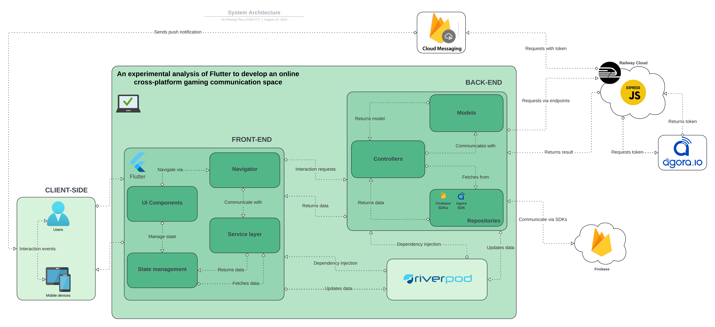
Figure 1. System architecture
This image shows the architecture of the system in detail, the flow of data, as well as how the components in the system communicate and coordinate with each other to create an application with efficiency and smoothness. Below is a detailed explanation:
First, the end user will interact with their device, their actions such as touching, swiping, and long pressing will trigger different events in the application. These events will be registered by the touch screen, traverse through the layers of the operating system, and reach the application, where it will act based on that event. When these events reach the application layer, where the Flutter framework is used to build the application. Flutter manages the UI elements widgets along with the ability to trigger events based on user interactions. Based on the event, state management will display the corresponding information, for example, if the user clicks on the login button, the state of the login screen will change to true, based on this state variable, the login button will display a loading widget for the user to know that the system is processing their login request. The navigator acts as a navigation manager, helping users move between screens with certain role constraints. The service layer is the last component of the UI layer, acting as a bridge between backend services and processing data before it can be displayed on the UI. For example, when processing streams from Firebase, this service layer will display the results, loading status, or display errors based on the state of the flow.
Still based on the input events, Flutter will pass that event to the Back end, where the Controller classes will communicate and use the Model and Repository classes. The Model classes represent Firebase Firestore collections such as UserModel, Communities, and Conversations, containing the corresponding data of each entity that exists in the system. Specifically, with the action of sending a friend request, FriendController will create a FriendRequest model with data from the sender and the recipient, and finally, FriendRepository will be responsible for sending this data to Firestore, and the recipient will receive that invitation. At the same time, it also creates a NotificationModel with similar data, PushNotificationController and PushNotificationRepository will act to send a request to Firebase Cloud Messaging (FCM) based on the recipient's device token, resulting in the recipient receiving a push notification about the person who just sent them the friend request.
As for Riverpod, this is a Flutter package used for dependency injection in the application. It facilitates the connection between the Front-end service layer to call the Controller functions on the Back-end side and return the result for the Front-end to process based on the state of this result.
Firebase Firestore is used as the primary database for storing and retrieving app data. It allows data to be synchronized in real-time between users and devices. Firebase Cloud Messaging (FCM) is a Firebase service that supports push notifications to keep users informed of updates or messages based on their actions (sending friend requests, accepting invitations, getting posts approved)
Agora.io is a service that provides real-time communication features such as voice calls, video calls, and live streaming, which are essential for a platform that supports in-app communication.
Express.js is a back-end web application framework for handling HTTP requests and routing, session management, database operations, and integration with third-party services like Firebase and Agora. While Dart is perfectly capable of handling API calls without Express.js, the primary reason for using Express.js in a project is for security and complex server-side data management. Express.js helps protect sensitive business logic from client-side interference and provides a robust foundation for handling tasks that Dart when running on the client, cannot perform safely or efficiently.

Technical design

Use case

Overall Use case diagram
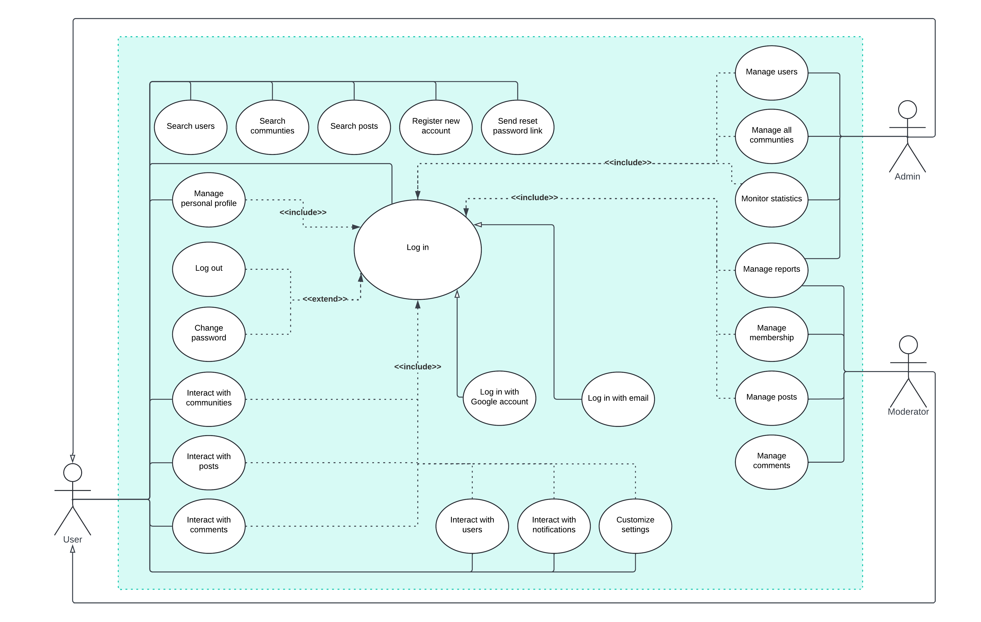
Figure 2. Overall use cases
Table 5. Log in
Use case name: Log in | ID: UC01 | Priority: High
Description: This use case describes how user can log into the application
Trigger:
Type:
Preconditions:
Normal course:
Alternative flow:
Postconditions:
Exceptions:

Table 6. Log in with Google account
Use case name: Log in with Google account | ID: UC02 | Priority: High
Description: This use case describes how users can log into the application via Google account
Trigger: The user clicks on the "Join with Google" button on the authentication screen
Type: External
Preconditions:
- The user must have atleast ONE Google account
Normal course:
- The user enters the application
- The user chooses the “Join with Google” button
- The application prompts the user to choose their account, or enter a new one if there is no Google account exists on their device
- The user chooses one account
- The application receives authentication from Firebase and logs the user in
Alternative flow: N/A
Postconditions: The user successfully logs in to the application using their Google account.
Exceptions:
- The user denies access to the Google account.
- The user enters incorrect Google credentials.
- The internet connection is interrupted during the process

Table 7. Log in with email account
Use case name: Log in with email account | ID: UC03 | Priority: High
Description: This use case describes how users can log into the application via email account
Trigger: The user clicks on the "Join with Email" button on the authentication screen
Type: External
Preconditions:
Normal course:
- The user enters the application
- The user chooses the “Join with Email” button
- The application prompts the user to enters email and password
- The user enters the credentials
- The application receives authentication from Firebase and logs the user in
Alternative flow: N/A
Postconditions: The user successfully logs in to the application using their email account.
Exceptions:
- The user enters incorrect credentials.
- The internet connection is interrupted during the process

Table 8. Register new account
Use case name: Register new account | ID: UC04 | Priority: High
Description: This use case describes how users can log into the application via email account
Trigger: The user clicks on the "Join with Email" button on the authentication screen
Type: External
Preconditions:
Normal course:
- The user enters the application
- The user chooses the “Join with Email” button
- The application prompts the user to enters email and password
- The user enters the credentials
- The application receives authentication from Firebase and logs the user in
Alternative flow: N/A
Postconditions: The user successfully logs in to the application using their email account.
Exceptions:
- The user enters incorrect credentials.
- The internet connection is interrupted during the process

Specific Use case diagram

Admin & Moderator use cases
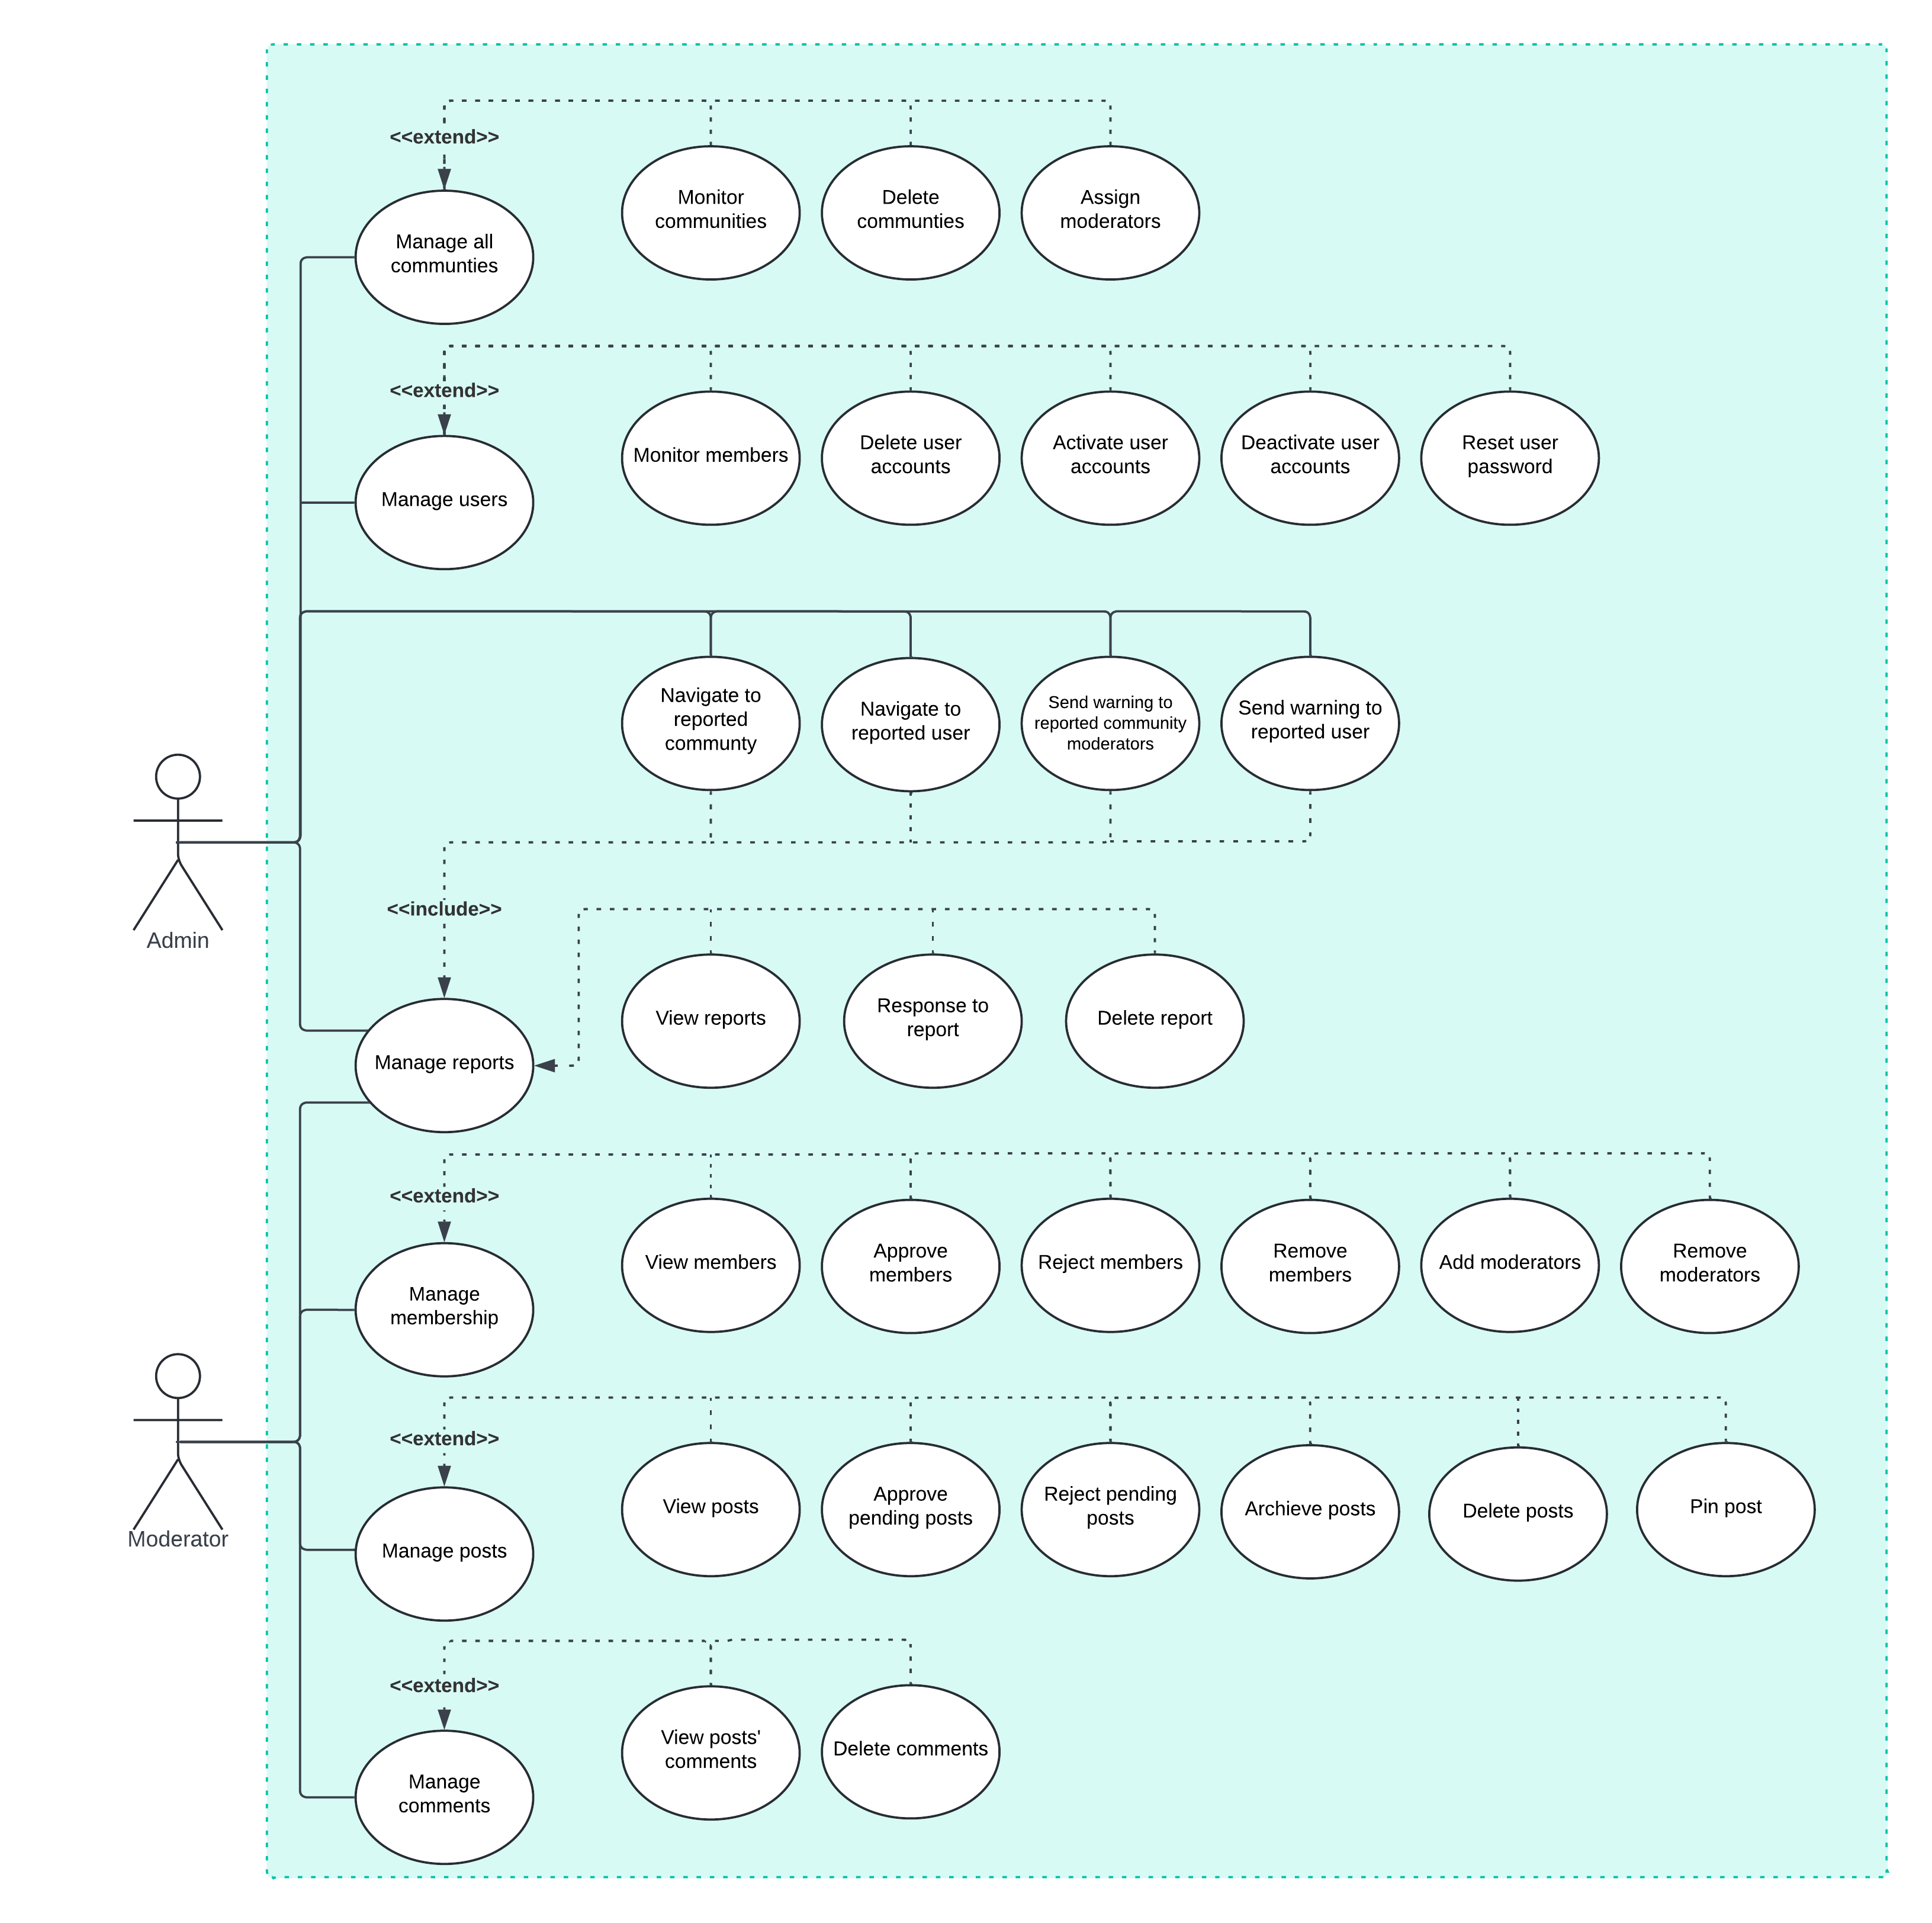
Figure 3. Admin & Moderator specific use cases
Table 9. Manage all communities
Use case name: Manage all communities | ID: UC05 | Priority: Medium
Description: This use case describes how administrators can manage the communities of the system
Trigger:
Type: External
Preconditions:
Normal course:
- The user enters the application
- The user chooses the “Join with Email” button
- The application prompts the user to enters email and password
- The user enters the credentials
- The application receives authentication from Firebase and logs the user in
Alternative flow: N/A
Postconditions: The user successfully logs in to the application using their email account.
Exceptions:
- The user enters incorrect credentials.
- The internet connection is interrupted during the process

User specific use cases
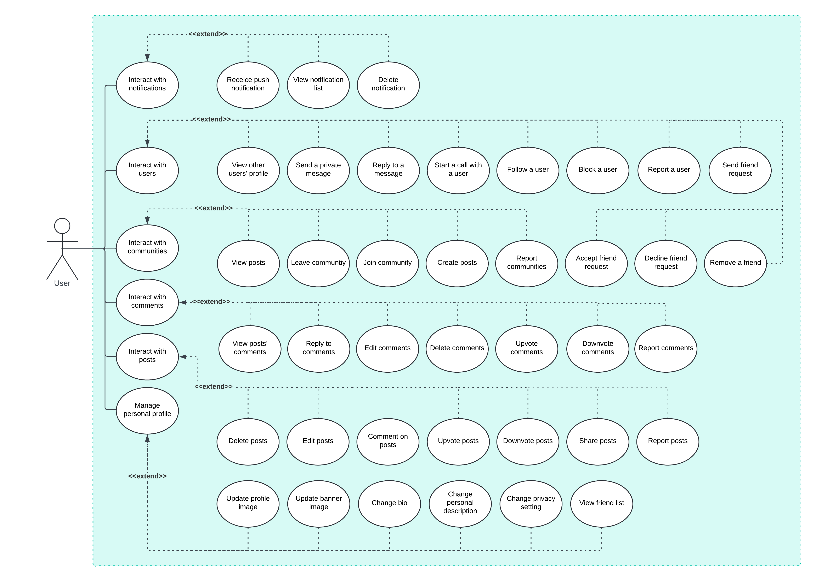
Figure 4. User specific use cases

Sitemap

Activity diagram

Logging in via Google
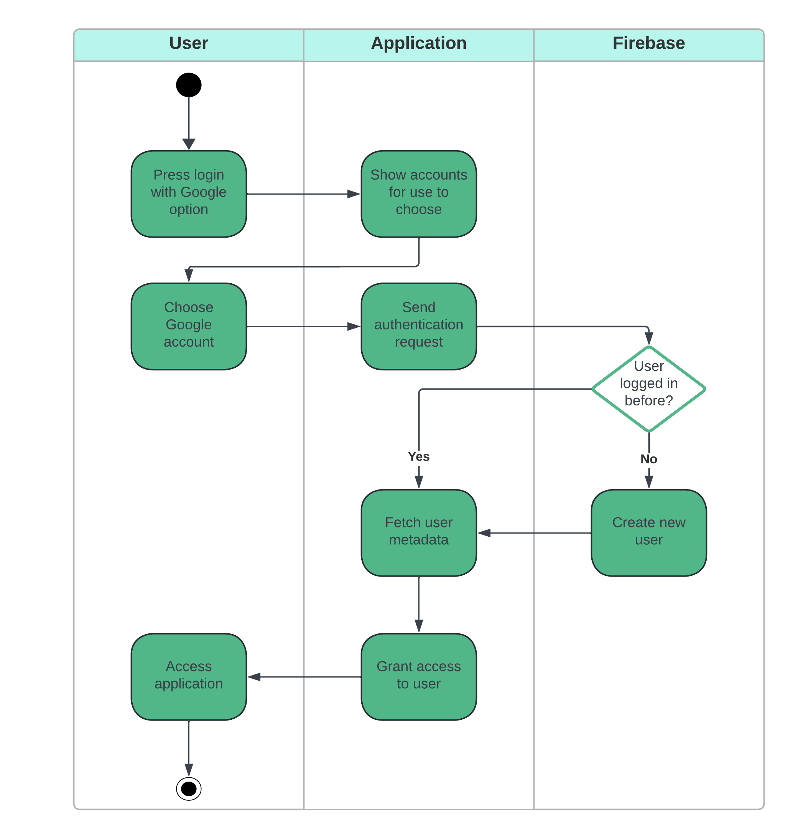
Figure 5. Login via Google
This image shows an activity diagram of a user logging into an app using a Google account, integrated with Firebase for user authentication. It starts with the user tapping the Sign in with Google option. The app then displays the Google accounts available on the device. Once the user has selected an account, the app sends an authentication request to Firebase, which checks to see if the user has logged in before. If they have, Firebase retrieves the existing user information and sends it to the app. If not, Firebase creates a new account. Finally, once the user information is confirmed, the app grants access and allows the user to continue using the app.

Forgetting password
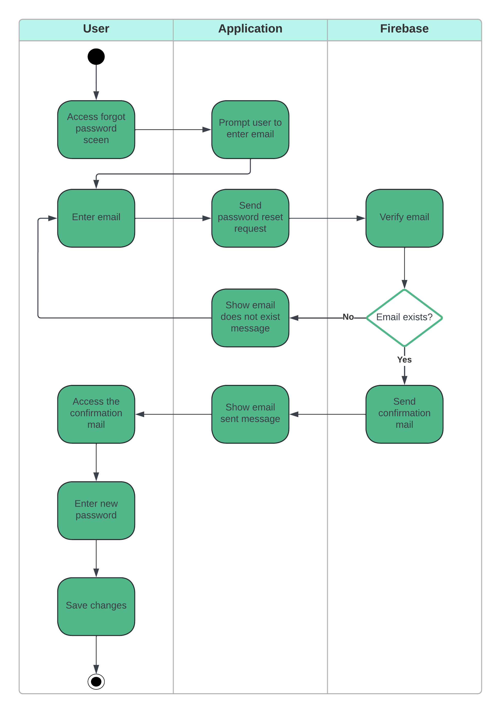
Figure 6. Forgetting password
This diagram illustrates the process of a user resetting their password using Firebase services. It starts when the user accesses the forgot password screen and is asked by the application to enter an email address. The application then sends a password reset request to Firebase and it checks to see if the email exists. If the email does not exist, the application displays an error message to the user. Otherwise, if the email exists, Firebase sends a confirmation email with a password reset link to the user. The user will then receive an email, click on the confirmation link and they will be redirected to the screen to enter a new password and save the changes, the process ends.

Creating post
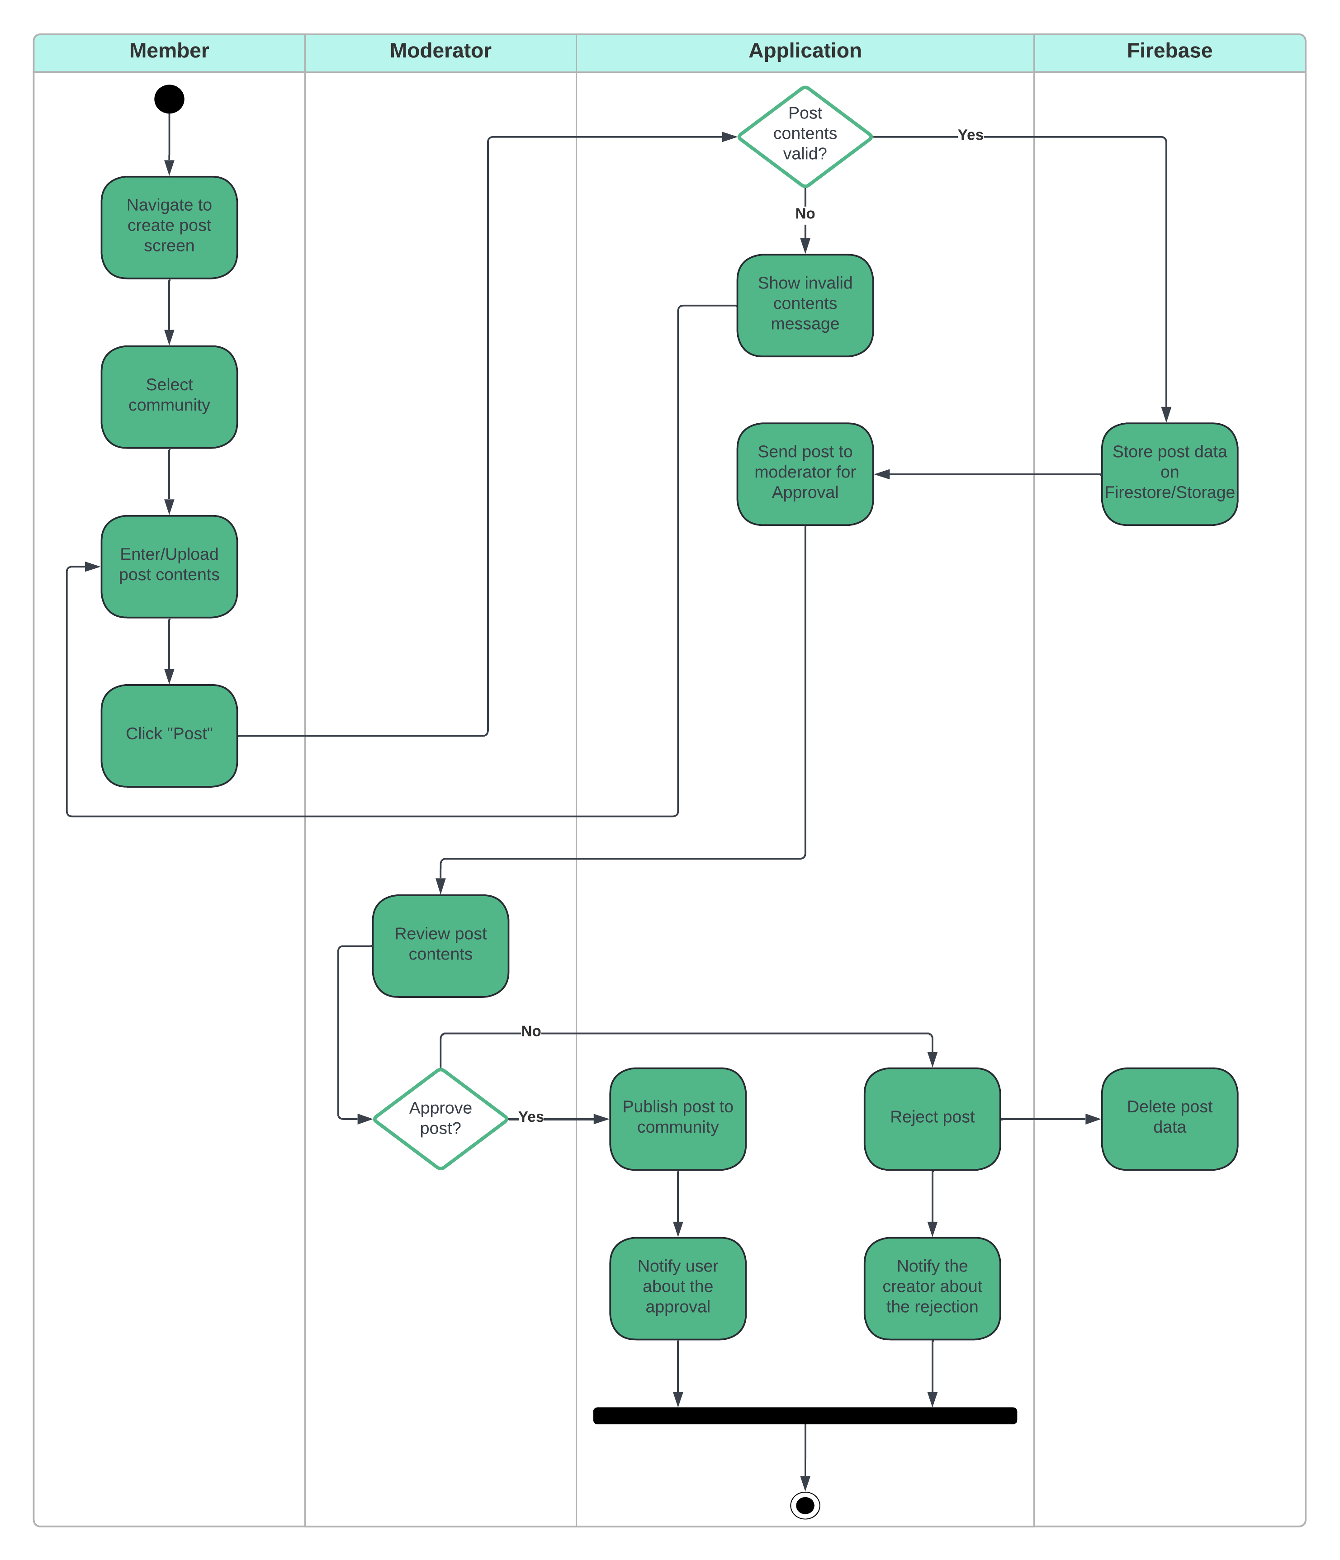
Figure 7. Creating post
This is an activity diagram that describes the process a post goes through before it can be displayed in the newsfeed. The process begins when the user navigates to the post creation screen, selects a community, enters content, and presses the “Post” button. The app checks the validity of the post content, and if it is invalid, it displays an error message to the user. If the content is valid, the post is sent to a moderator for review. The moderator reviews the content and decides whether to approve or reject the post. If the post is approved, it is published to the community and the poster is notified that their post has been approved. Conversely, if the post is rejected, the post data is deleted from Firebase, the member is notified of the rejection, and the process ends.

Modifying Community Information
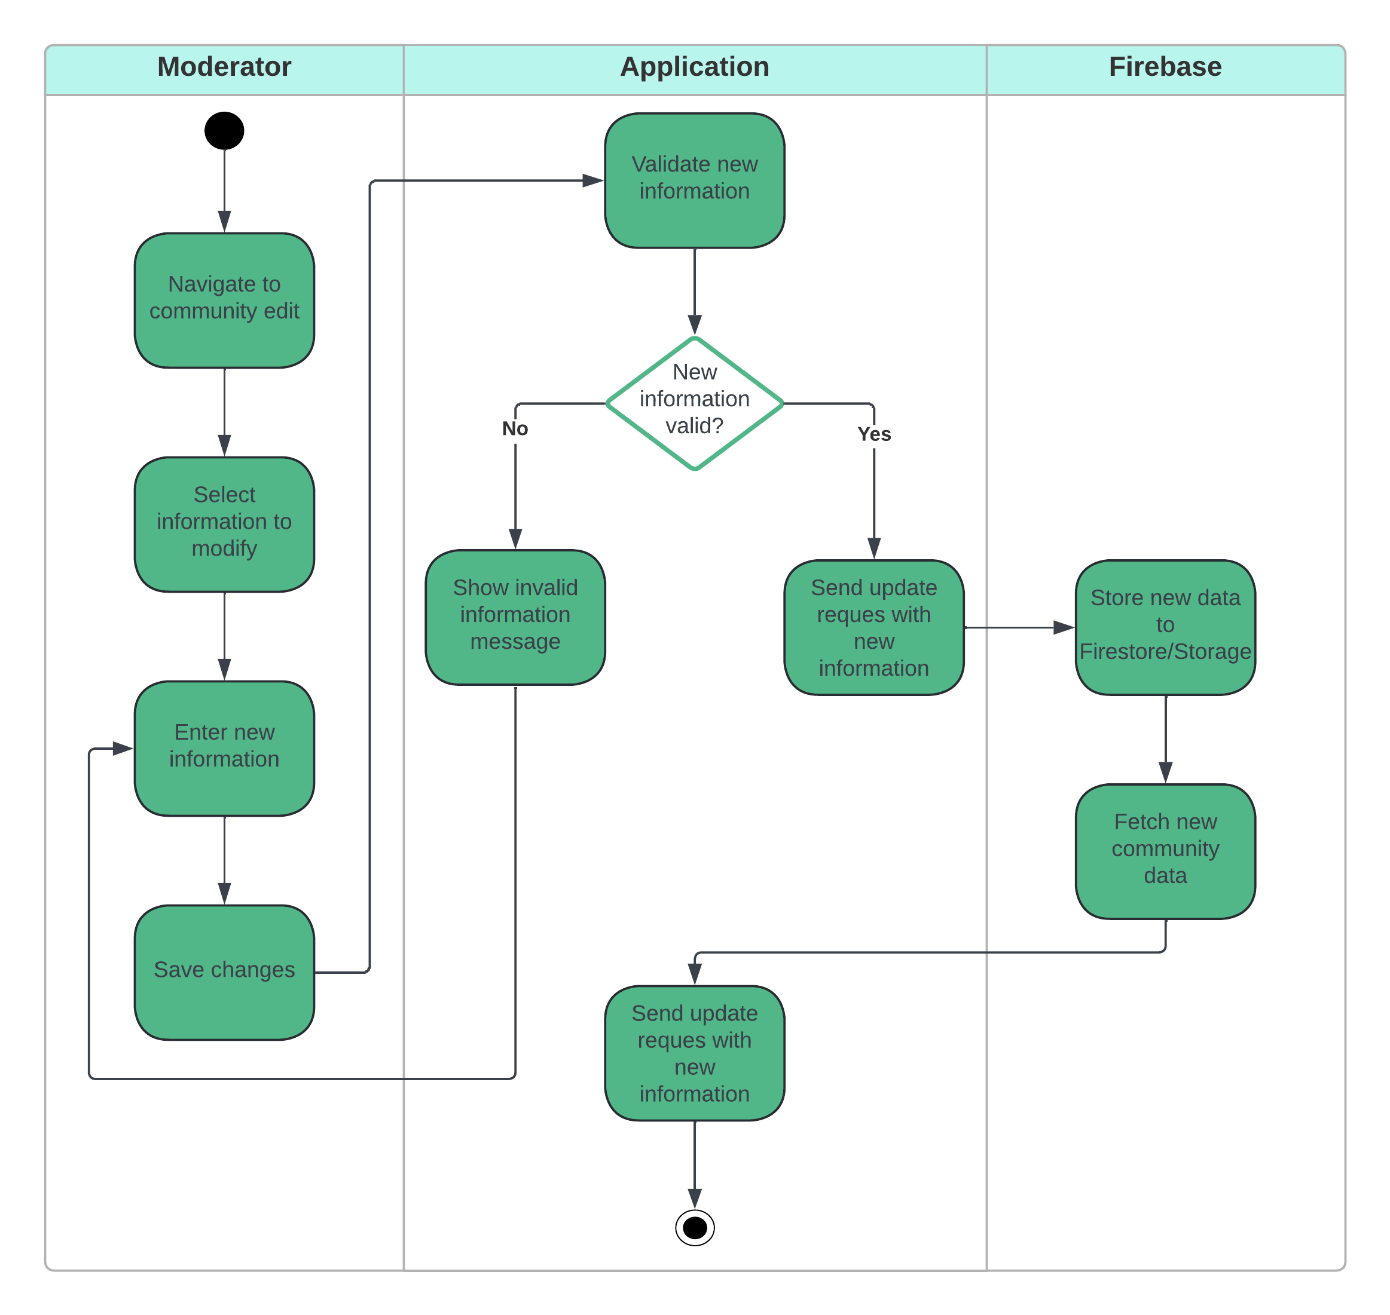
Figure 8. Modifying Community information
Another activity diagram in the project is the community information editing diagram, which is performed by the moderator. The process starts when the moderator navigates to the community information editing screen. They will select the information to change and enter the new information. The application will then check the validity of the new information. If the information is invalid, the application will display an error message and ask the moderator to edit it again. If it is valid, the new data will be sent to Firebase for storage and updating. Once the process is complete, the application will retrieve the latest community data and display a notification that the community information has been successfully changed to the moderator, and the process is complete.

Messaging another user
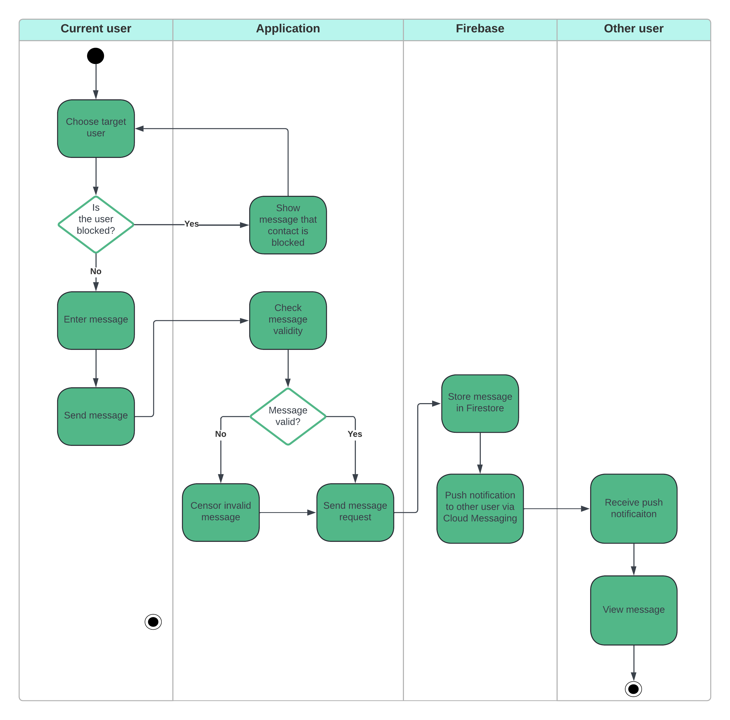
Figure 9. Messaging another user
The diagram depicting the messaging activity between two users in the application is shown in the image above. It starts when the current user selects the target user to message. The application will check if the target user is blocked. If yes, the application will display a notification that the contact is blocked and stop the activity. If not, the current user can enter the content and send it. The application will check the validity of the message, if invalid, it will be hidden. Otherwise, the application will send a request to store the message to Firebase, where it will store the message in Firestore and send a push notification to the target user via Cloud Messaging. The target user will receive the notification and see the received message in the chat screen between the two people, and the activity ends.

Calling another user
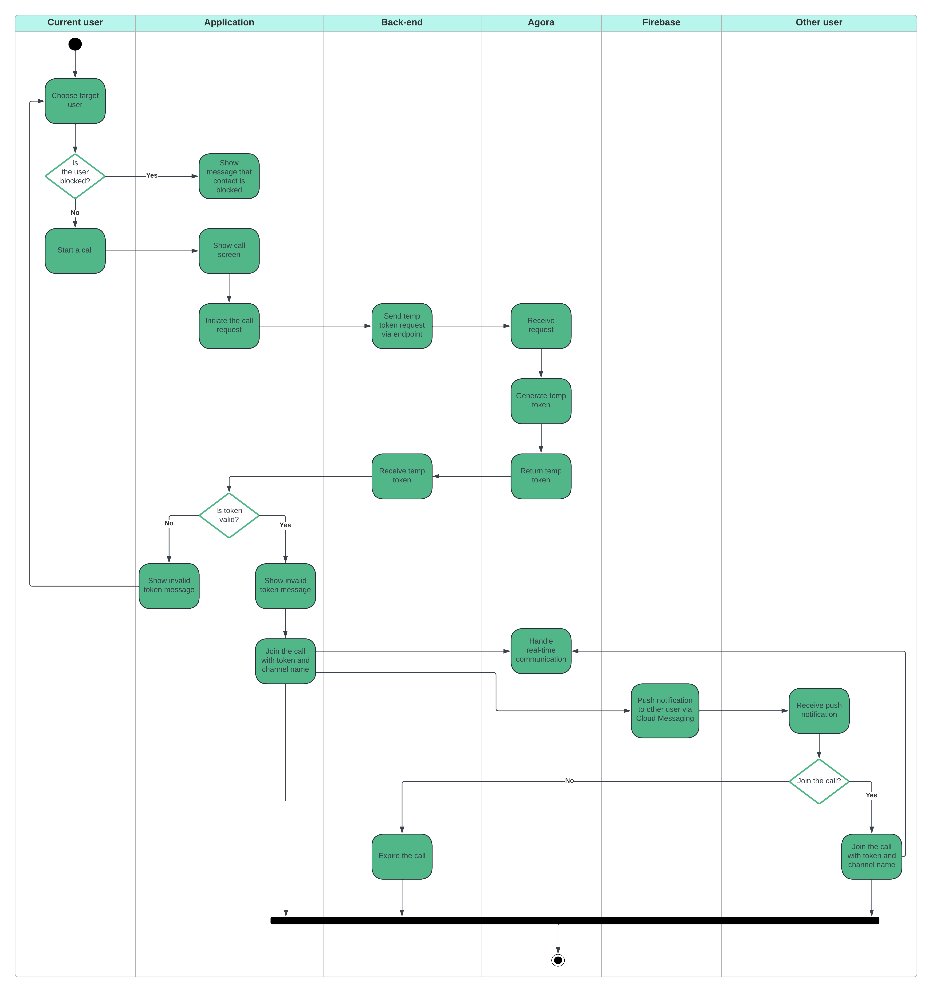
Figure 10. Calling another user
The final activity diagram illustrates the process of making a call between two users in the app, using Agora and Firebase services to get the Agora Temp Token and push notifications. The process starts quite similar to the messaging process. If the target user is blocked, the process stops, otherwise the call proceeds.
The app will then display the call screen and initiate a call request to the Back-end, which will send a request to create a temp token to Agora, where the token will be generated and returned to the Back-end, the app that receives the token will check if the token is valid. If not, the current user will receive an error message. If the token is valid, the user will join the call with the token and channel name.
At the same time, Firebase will send a push notification to the target user via Cloud Messaging, notifying them of the incoming call. If the target user does not join the call, the temp token will be destroyed and expire after a certain period. Otherwise, both will join the call.

Class Diagram

Entity Relationship Diagram

Prototype

Introduction

Low-fidelity prototypes

IMPLEMENTATION

Introduction

Implementation Issues
Development technologies
No. | Technology | Role
Explain more about your final choices
(For web, mobile app, blockchain, CV or AI system)
Provide github link, admin account of system and database (if any)
  - Project Structure
Source code
  - Back-end implementation
Show the main functions/features, the remarkable algorithms or the important formula(s) in your project
  - Screenshots (không cần chụp hết, mỗi hình cần phải giải thích ra)

PRODUCT TESTING/TEST DATA

Introduction

Test cases

Evaluation

Introduction
Summarise your key thoughts about the project

Heuristic Evaluation (use Jakob Nielsen’s 10 usability heuristics in UI/UX design - HCI)

Usability Testing
- How did you conduct the survey?
- Who are the participants and how will you find participants? How many?
- What do you want to test? (2 hypotheses)
- Show the list of questions (quantitative and qualitative)
- Analyze the final results of survey and evaluate your hypotheses.
Communicate research outcomes in an appropriate manner for the intended audience.

Note:
- The final results should be included in an Appendix

Critical Appraisal

Your process – the entire project from start to finish

Your product – objective evaluation of the thing you made

Your person - yourself – what did you bring to the project, how have you changed through this experience, what have you learned – you may resort to first person grammar here but you get extra brownie points if you can do this in the third person.

Conclusion
What went well?
What did not well?
What have learned from this project?
Future works

REFERENCES / BIBLIOGRAPHY
Aichner, T. et al. (2021) ‘Twenty-Five Years of Social Media: A Review of Social Media Applications and Definitions from 1994 to 2019’, Cyberpsychology, Behavior, and Social Networking [Preprint]. Available at: https://doi.org/10.1089/cyber.2020.0134.
AminiMotlagh, M., Shahhoseini, H. and Fatehi, N. (2022) ‘A reliable sentiment analysis for classification of tweets in social networks’, Social Network Analysis and Mining, 13(1), p. 7. Available at: https://doi.org/10.1007/s13278-022-00998-2.
Ancillai, C. et al. (2019) ‘Advancing social media driven sales research: Establishing conceptual foundations for B-to-B social selling’, Industrial Marketing Management, 82, pp. 293–308. Available at: https://doi.org/10.1016/j.indmarman.2019.01.002.
Antonakaki, D., Fragopoulou, P. and Ioannidis, S. (2021) ‘A survey of Twitter research: Data model, graph structure, sentiment analysis and attacks’, Expert Systems with Applications, 164, p. 114006. Available at: https://doi.org/10.1016/j.eswa.2020.114006.
Ariantini, K.P. et al. (2021) ‘Integrating Social Media into English Language Learning: How and to What Benefits According to Recent Studies’, NOBEL: Journal of Literature and Language Teaching, 12(1), pp. 91–111. Available at: https://doi.org/10.15642/NOBEL.2021.12.1.91-111.
Avdic, D. (2019) ‘React native vs xamarin-mobile for industry’.
Axelsson, O. and Carlström, F. (2016) ‘Evaluation targeting react native in comparison to native mobile development’.
Ayezabu, A.Z. (2022) ‘Supabase vs Firebase: Evaluation of performance and development of Progressive Web Apps’.
Bilgin, C. (2016) Mastering Cross-Platform Development with Xamarin. Packt Publishing Ltd.
Blanco, J.Z. and Lucrédio, D. (2021) ‘A holistic approach for cross-platform software development’, Journal of Systems and Software, 179, p. 110985. Available at: https://doi.org/10.1016/j.jss.2021.110985.
Brito, H. et al. (2018) ‘JavaScript in mobile applications: React native vs ionic vs NativeScript vs native development’, in 2018 13th Iberian Conference on Information Systems and Technologies (CISTI). 2018 13th Iberian Conference on Information Systems and Technologies (CISTI), pp. 1–6. Available at: https://doi.org/10.23919/CISTI.2018.8399283.
Challapalli, S.S.N. et al. (2021) ‘Web Development and performance comparison of Web Development Technologies in Node. js and Python’, in. 2021 International Conference on Technological Advancements and Innovations (ICTAI), IEEE, pp. 303–307.
Chougale, P. et al. (2021) ‘Firebase-overview and usage’, International Research Journal of Modernization in Engineering Technology and Science, 3(12), pp. 1178–1183.
Dwivedi, Y.K. et al. (2023) ‘Social Media Adoption, Usage And Impact In Business-To-Business (B2B) Context: A State-Of-The-Art Literature Review’, Information Systems Frontiers, 25(3), pp. 971–993. Available at: https://doi.org/10.1007/s10796-021-10106-y.
Eskola, R. (2018) ‘React Native Performance Evaluation’.
Fentaw, A.E. (2020) ‘Cross platform mobile application development: a comparison study of React Native Vs Flutter’.
Figueiredo, C. (2022) ‘Trust and Safety and Fair Play in Video Games: Intentionally Designing Positive Communities’, in Game Usability. 2nd edn. CRC Press.
GÜLCÜOĞLU, E., USTUN, A.B. and Seyhan, N. (2021) ‘Comparison of Flutter and React Native Platforms’, Journal of Internet Applications and Management, 12(2), pp. 129–143.
Ivanov, D. and Petrova, A. (2024) ‘Serverless Computing Architectures and Applications in AWS’, MZ Journal of Artificial Intelligence, 1(1), pp. 1–10.
Kaplan, A.M. and Haenlein, M. (2010) ‘Users of the world, unite! The challenges and opportunities of Social Media’, Business horizons, 53(1), pp. 59–68.
Karim, F. et al. (2020) ‘Social media use and its connection to mental health: a systematic review’, Cureus, 12(6).
Kausar, S., Tahir, B. and Mehmood, M.A. (2021) ‘Towards Understanding Trends Manipulation in Pakistan Twitter’. arXiv. Available at: https://doi.org/10.48550/arXiv.2109.14872.
Khawas, C. and Shah, P. (2018) ‘Application of firebase in android app development-a study’, International Journal of Computer Applications, 179(46), pp. 49–53.
Khoirom, S. et al. (2020) ‘Comparative analysis of Python and Java for beginners’, Int. Res. J. Eng. Technol, 7(8), pp. 4384–4407.
Kuitunen, M. (2019) ‘Cross-Platform Mobile Application Development with React Native’. Available at: https://trepo.tuni.fi/handle/123456789/27139 (Accessed: 16 April 2024).
Lee, S., Rojas, H. and Yamamoto, M. (2022) ‘Social Media, Messaging Apps, and Affective Polarization in the United States and Japan’, Mass Communication and Society, 25(5), pp. 673–697. Available at: https://doi.org/10.1080/15205436.2021.1953534.
Marthasari, G., Suharso, W. and Ardiansyah, F.A. (2018) ‘Personal Extreme Programming with MoSCoW Prioritization for Developing Library Information System’, Proceeding of the Electrical Engineering Computer Science and Informatics, 5(1), pp. 537–541.
Nabiil, A. et al. (2023) ‘Performance Analysis on Web Development Programming Language (Javascript, Golang, PHP)’, in. 2023 International Conference on Information Technology and Computing (ICITCOM), IEEE, pp. 6–11.
Nawrocki, P. et al. (2021) ‘A Comparison of Native and Cross-Platform Frameworks for Mobile Applications’, Computer, 54(3), pp. 18–27. Available at: https://doi.org/10.1109/MC.2020.2983893.
Olan, F. et al. (2022) ‘Fake news on Social Media: the Impact on Society’, Information Systems Frontiers [Preprint]. Available at: https://doi.org/10.1007/s10796-022-10242-z.
Rogerson, S. (2021) The Evolving Landscape of Ethical Digital Technology. New York: Auerbach Publications. Available at: https://doi.org/10.1201/9781003203032.
Shevtsiv, N. and Striuk, A. (2021) ‘Cross platform development vs native development’, in. CEUR Workshop Proceedings.
Sun, H. et al. (2018) ‘Efficient dynamic analysis for Node. js’, in. Proceedings of the 27th International Conference on Compiler Construction, pp. 196–206.
Uong, T.G.T., Nguyen, D.K. and Nguyen, H.N. (2022) ‘Teachers’ Feedback on Using Discord as an Online Learning Platform’, International Journal of TESOL & Education, 2(4), pp. 84–104. Available at: https://doi.org/10.54855/ijte.22246.
Uunonen, S. (2023) ‘Backend as a service in web development’.
Wang, P.-W. et al. (2020) ‘COVID-19-Related Information Sources and the Relationship With Confidence in People Coping with COVID-19: Facebook Survey Study in Taiwan’, Journal of Medical Internet Research, 22(6), p. e20021. Available at: https://doi.org/10.2196/20021.
Wu, W. (2018) ‘React Native vs Flutter, Cross-platforms mobile application frameworks’.
Zayat, W. and Senvar, O. (2020) ‘Framework study for agile software development via scrum and Kanban’, International journal of innovation and technology management, 17(04), p. 2030002.
Zhao, X., Liang, J. and Wang, J. (2021) ‘A community detection algorithm based on graph compression for large-scale social networks’, Information Sciences, 551, pp. 358–372. Available at: https://doi.org/10.1016/j.ins.2020.10.057.
Zhou, J. et al. (2021) ‘Examination of Community Sentiment Dynamics due to COVID-19 Pandemic: A Case Study from a State in Australia’, SN Computer Science, 2(3), p. 201. Available at: https://doi.org/10.1007/s42979-021-00596-7.
Zohud, T. and Zein, S. (2021) ‘Cross-Platform Mobile App Development in Industry: A Multiple Case-Study’, International Journal of Computing, pp. 46–54. Available at: https://doi.org/10.47839/ijc.20.1.2091.
Go.dev, 2024. Documentation. [Online] Available at: https://go.dev/doc/ [Accessed 22 August 2024].
Scrum.org, 2024. What is Scrum?. [Online] Available at: https://www.scrum.org/learning-series/what-is-scrum/ [Accessed 22 August 2024].
- Project Proposal
Have several appendices (A,B,C…). These should include detailed and technical documentation such as table of results, diagrams, program source code, etc, which are essential parts of the project but not directly a part of the main discussion in the report. All contents of appendices should be exclusively, products of the student’s own work.

Other materials used during the project work (such as information from user manuals, interview notes, etc), which it is necessary to include, should if possible be summarized to only a few pages before entering into the appendix. Original copies of such material should be kept by the student and may be required to be produced as supporting evidence of their work.

Examples of key coding may be provided in an Appendix but generally it should be uploaded via teachmat or on the P drive with its associated software.

